

**HANOI UNIVERSITY OF SCIENCE   
AND TECHNOLOGY**

SCHOOL OF ELECTRICAL ENGINEERING

**PROJECT REPORT**

DCS & SCADA

EE4364E

**Topic:** *“Clean in place control system for beer factory.”*

|  |  |
| --- | --- |
| Point | Instructor’s comments |
|  |  |

**Instructor:** PhD. Đào Quý Thịnh

**Group 20:** *<Class ID: 143343>*

|  |  |  |
| --- | --- | --- |
| # | Student Name | Student ID |
| 1 | Nguyễn Phú Quyền | 20192246 |
| 2 | Phạm Tiến Thành | 20192252 |
| 3 | Nguyễn Trọng Tín | 20192255 |
| 4 | Nguyễn Huy Hùng | 20200259 |

***Hanoi, 2023***

**ABSTRACT**

The "Clean in Place Control System for Beer Factory" project aims to develop an automated solution for cleaning equipment and pipelines in a beer factory. The project involves designing and implementing a Clean in Place (CIP) control system that uses sensors, actuators, and programmable logic controllers (PLCs) to monitor and control cleaning parameters. The system aims to improve operational efficiency, reduce cleaning time, enhance product quality, and minimize contamination risks. Successful implementation of the CIP control system can serve as a model for other beverage manufacturing industries, promoting automation and standardization in ensuring cleanliness and product quality.

Finally, we would like to express our gratitude to our instructor – Mr. Đào Quý Thịnh, who guided us through this project.

**Table of contents**

Chapter 1: Introduction 7

1.1. Beer Factory 7

1.2. Clean in Place (CIP) System 8

Chapter 2: System Design 9

2.1. Architecture 9

2.2. Instrumentation 9

(A) Level Sensor 9

(B) Valves 9

(C) Pumps 10

(D) Motor 10

2.3. CIP control system 10

(A) S7 – 1500 1512C-1 PN 11

(B) TP1200 comfort 12

(C) WinForms C# 12

(D) Microsoft SQL Server 14

2.4. I/O Variables 15

2.5. Wiring Diagram 16

2.6. Control sequence 17

(A) User Login 17

(B) Mode selection 17

(C) Step 1: Pre-empty 18

(D) Step 2: Re-supply 18

(E) Step 3+5+7: Pre-rinse / Intermediate rinse / Final rinse 19

(F) Step 4+6: Caustic wash / Acid wash 19

2.7. Authorization Distribution 19

Chapter 3: Simulation 21

3.1. User Login 21

3.2. Admin forms 21

(A) Setting 21

(B) Logs 22

(C) Report 22

3.3. Operator forms 23

3.4. Guest view 24

3.5. HMI for operator 24

Chapter 4: Conclusion 25

**Table of figures**

Figure 1. Beer components 7

Figure 2. Brewing process 7

Figure 3. CIP System 8

Figure 4. System Architecture 9

Figure 5. CPU S7 – 1500 1512C-1 PN 11

Figure 6. TP1200 simulated using WinCC RT Professional 12

Figure 7. WinForms C# Splash art 13

Figure 8. SQL Server structure 14

Figure 9. Inputs for CPU 15

Figure 10. Outputs for CPU part 1 15

Figure 11. Outputs for CPU part 2 16

Figure 12. Wiring Diagram 16

Figure 13. User login control sequence 17

Figure 14. Mode control algorithm flowchart 17

Figure 15. Step 1 control algorithm flowchart 18

Figure 16. Step 2 control algorithm flowchart 18

Figure 17. Rinse step control algorithm flowchart 19

Figure 18. Caustic / Acid wash control algorithm flowchart 19

Figure 19. User, log and report database relationship 20

Figure 20. User login form 21

Figure 21. Administration settings 21

Figure 22. User logs 22

Figure 23. Reports 22

Figure 24. Operator forms 23

Figure 25. Operator report 23

Figure 26. Guest views 24

Figure 27. Resupply process 24

Figure 28. Pre rinse process 24

1. Introduction
   1. Beer Factory

Beer factories are essential components of the beverage industry, responsible for producing and distributing beer globally. These facilities combine traditional brewing techniques with modern technologies to transform raw ingredients into a variety of beer styles.

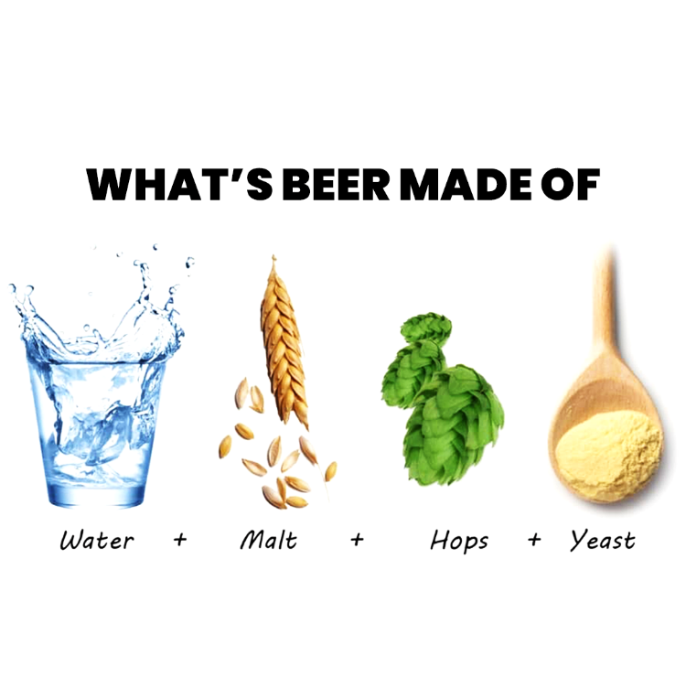

1. Beer components

With meticulous attention to detail and adherence to quality standards, beer factories employ advanced equipment and quality control measures to ensure consistent taste, purity, and safety.

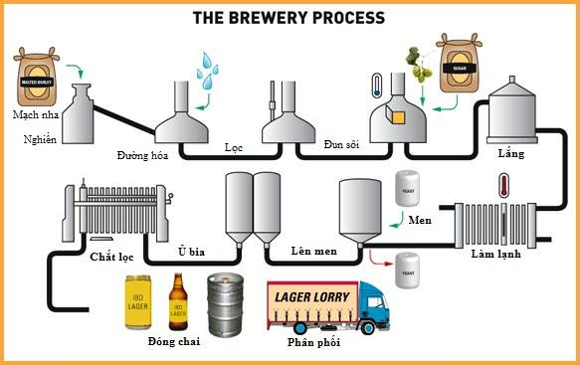

1. Brewing process
   1. Clean in Place (CIP) System

Clean in Place (CIP) systems have revolutionized the cleaning processes in various industries, including beer manufacturing. These automated systems eliminate manual labor, reduce downtime, and enhance cleanliness and hygiene standards. By utilizing sensors, actuators, and programmable logic controllers (PLCs), CIP systems monitor and control cleaning parameters, resulting in improved operational efficiency and product quality.



1. CIP System

1. System Design
   1. Architecture

The system architecture includes 4 layers: supervisory, communication, local control and field (I/O).

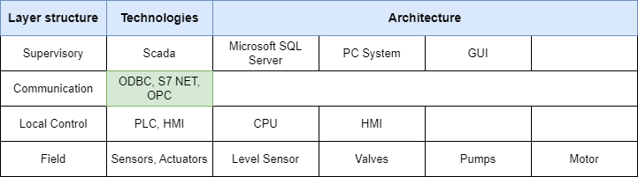

1. System Architecture

The supervisory layer includes an SQL server for database management, a GUI application to operate on PC system as a master terminal unit to supervise and control the remote terminal unit. The communication layer includes protocols such as ODBC, S7 NET. The local control includes SIMATIC CPUs, HMIs and modules. The field layer includes level sensors, valves, pumps and motor.

* 1. Instrumentation
     1. Level Sensor

LMT121 is a level sensor manufactured by a company called Endress+Hauser. The LMT121 is part of their Liquiphant series of point level switches. LMT121 offers reliable operation, liquids compatibility, process conditions, easy installation fail-safe operation and hazardous are certification.

* + 1. Valves

Using a butterfly valve, specifically a DN250 size with a pneumatic actuator AT14, can offer several advantages and considerations when used in a CIP (Clean in Place) system.

Advantages: Flow Control, Quick Operation, Hygienic Design and Compact Size.

Disadvantages: Sizing, Actuator Control, Maintenance and Reliability.

* + 1. Pumps

Based on research conducted, the SUDMO KRP 50/127-1.510 pump was choose. Advantages:

+ Efficiency: SUDMO pumps are known for their efficient performance, which can help in achieving optimal cleaning results in a CIP system.

+ Hygienic Design: SUDMO pumps are typically designed with hygienic considerations, making them suitable for use in the food and beverage industry and other applications with strict hygiene requirements.

+ Reliability: SUDMO is a reputable manufacturer known for producing reliable and high-quality pumps, which can contribute to the overall reliability and uptime of the CIP system.

+ Product Range: SUDMO offers a wide range of pumps, allowing for flexibility in selecting a model that suits the specific flow rate, pressure, and requirements of the CIP system.

There are also disadvantages:

+ Cost: Depending on the specific model and features, SUDMO pumps may be relatively more expensive compared to some other pump brands available in the market.

+ Specific Application Considerations: The suitability of the SUDMO KRP 50/127-1.510 for the CIP system would depend on the specific application requirements, such as flow rate, pressure, and compatibility with the cleaning solution.

* + 1. Motor

When selecting a 3-phase gear motor for a CIP (Clean in Place) system, there are several factors to consider.

Power and Torque: 3-phase gear motors can deliver high power and torque, which is beneficial for driving pumps, agitators, or other equipment in a CIP system.

Speed Control: 3-phase motors offer flexibility of speed control, allowing you to adjust the motor's speed to meet specific cleaning requirements or optimize the process.

* 1. CIP control system

The choice of a CPU (Central Processing Unit) for a CIP (Clean in Place) control system depends on various factors: performance and processing power, networking capabilities, scalability and flexibility, robustness and reliability, integrated safety features, programming environment.

* + 1. S7 – 1500 1512C-1 PN

The S7-1500 series CPUs are known for their high-performance capabilities, offering fast processing speeds, efficient program execution, and advanced diagnostics. The "PN" in the model number indicates that the CPU supports PROFINET, a widely used industrial communication protocol. This allows for seamless integration with other PROFINET-compatible devices in the CIP system, such as I/O modules, HMIs (Human Machine Interfaces), and other controllers, enabling efficient data exchange and system coordination. The S7-1500 1512C-1 PN CPU also supports OPC UA (Unified Architecture), which is a widely adopted industrial communication protocol for interoperability and data exchange between different automation devices.

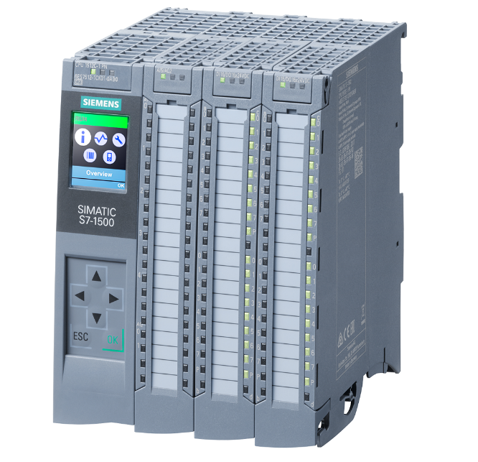

1. CPU S7 – 1500 1512C-1 PN

|  |  |
| --- | --- |
| **Product type designation** | CPU 1512C-1 PN |
| **Firmware version** | V2.8 |
| **Engineering with** | STEP 7 TIA Portal |
| **Supply voltage** | 24 V DC |
| **Power** | 10 w |
| **Work memory integrated (program)** | 250 kbyte |
| **Work memory integrated (data)** | Mbyte |
| **CPU processing times for bit** | 48 ns |
| **CPU processing times for word** | 58 ns |
| **Number of distributed IO systems** | 32 |
| **Clock synchronization** | supported |
| **Interface types** | RJ 45 (Ethernet) |
| **Web server** | HTTPS |
| **OPC UA** | Runtime license required |
| **RAM** | 1 MB |
| **ROM** | non-volatile |

* + 1. TP1200 comfort

The TP1200 Comfort is a Siemens HMI panel designed for CIP control systems. It features a large touchscreen display, user-friendly interface, flexible connectivity options, robust construction, advanced functionality, security features, and remote access capabilities. It provides an intuitive and reliable interface for monitoring and controlling CIP processes in industrial environments.

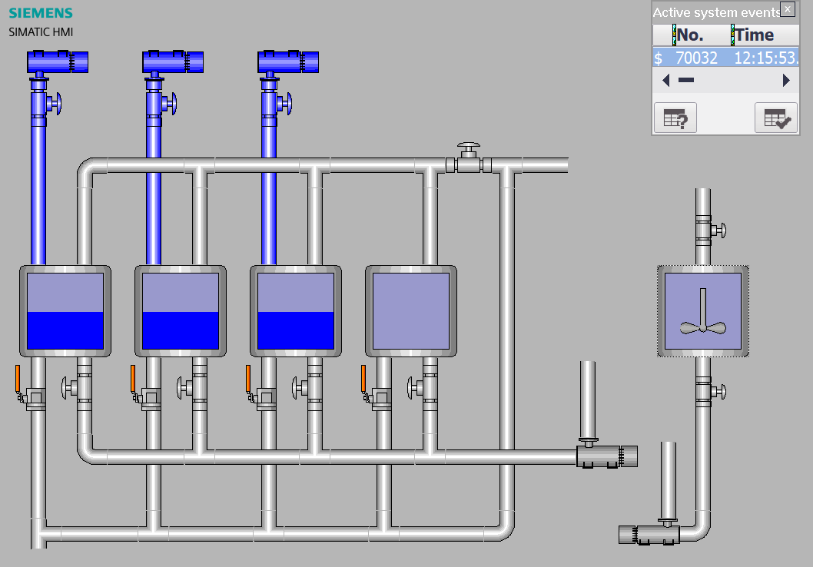

1. TP1200 simulated using WinCC RT Professional
   * 1. WinForms C#

WinForms in C# can be used to develop the user interface (UI) components of a CIP (Clean in Place) control system. With its drag-and-drop interface, event-driven programming model, data binding capabilities, and customization options, WinForms enables the creation of intuitive and visually appealing UIs for interacting with the CIP system. It seamlessly integrates with the backend logic written in C#, allowing for data processing, device communication, and control algorithm implementation. WinForms also supports error handling, data validation, reporting, and visualization, making it a versatile framework for building CIP control systems.

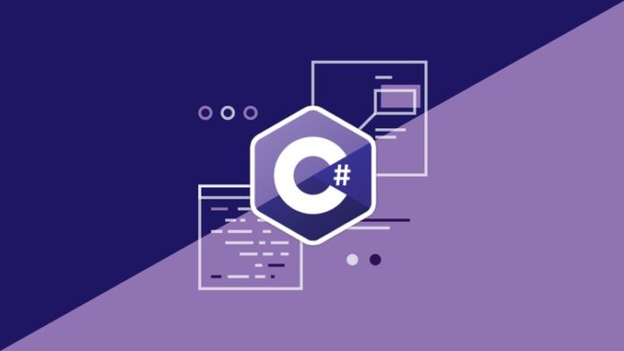

1. WinForms C# Splash art

In WinForms C# development for industrial automation, several libraries are commonly utilized:

* S7Net: S7Net is a C# library facilitating communication with Siemens S7 PLCs. It enables establishing connections, reading/writing data, and monitoring PLC variables.
* SymbolFactoryDotNet: SymbolFactoryDotNet is a C# library for creating graphical symbols and controls used in industrial automation UIs. It offers a range of customizable pre-built symbols for intuitive visualization.
* SQL: The SQL library enables C# applications to connect to and interact with databases such as Microsoft SQL Server, MySQL, or Oracle. It supports tasks like querying data, updating records, and executing stored procedures.
* PLC Libraries: PLC libraries include C# libraries developed by manufacturers or third-party developers to simplify PLC integration. These libraries provide features like data access, alarm handling, recipe management, and event logging for specific PLC models.
* OPC Libraries: OPC libraries are used to establish communication with OPC servers and devices. They enable C# applications to read/write data, subscribe to real-time updates, and handle alarms/events in OPC-enabled systems.

By incorporating S7Net, SymbolFactoryDotNet, SQL, PLC, and OPC libraries into WinForms C# applications, developers can create powerful and user-friendly interfaces for controlling and monitoring industrial automation systems, integrating with PLCs, databases, and OPC-enabled devices.

* + 1. Microsoft SQL Server

In a CIP (Clean in Place) control system, Microsoft SQL Server 2019 can be utilized for data storage and management, while integrating with other technologies such as the S7-1500 PLC, WinForms in C#, and OPC (OLE for Process Control).

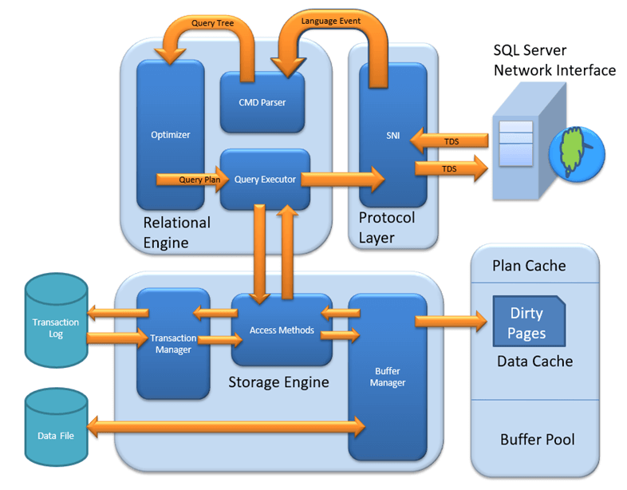

1. SQL Server structure

SQL Server 2019 is a robust relational database management system (RDBMS) provided by Microsoft. It offers a comprehensive suite of tools and features for storing, managing, and retrieving data. SQL Server can be used to store CIP process data, configuration settings, alarm/event logs, and other relevant information for the control system.

By combining Microsoft SQL Server 2019, S7-1500 PLC integration, WinForms in C#, and OPC libraries, a comprehensive CIP control system that leverages the power of a robust database for data storage and management, communicates with the PLC for process control, and provides a user-friendly interface for operators to monitor and interact with the system. OPC integration ensures seamless communication with OPC-enabled devices, enabling efficient data exchange and control within the CIP processes can be created.

* 1. I/O Variables

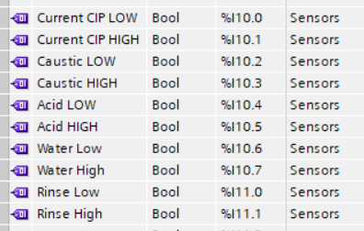

1. Inputs for CPU

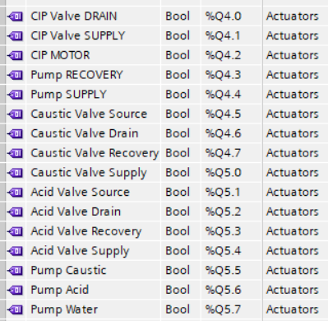

1. Outputs for CPU part 1

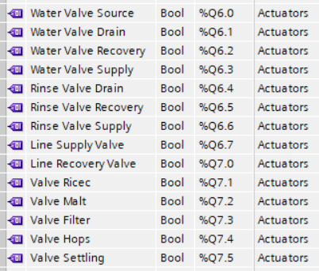

1. Outputs for CPU part 2
   1. Wiring Diagram

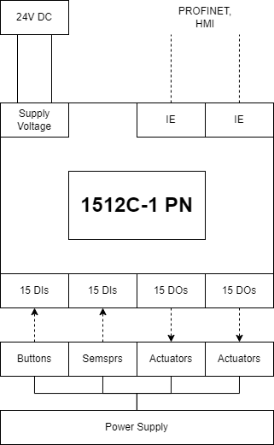

1. Wiring Diagram
   1. Control sequence
      1. User Login

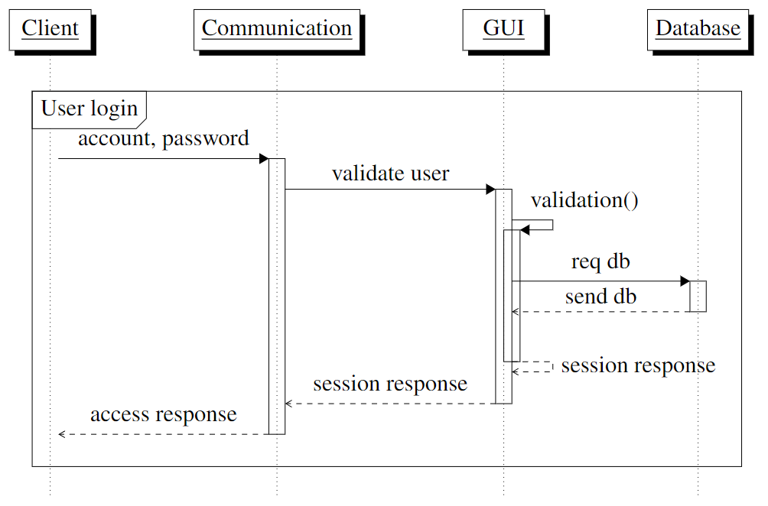

1. User login control sequence
   * 1. Mode selection

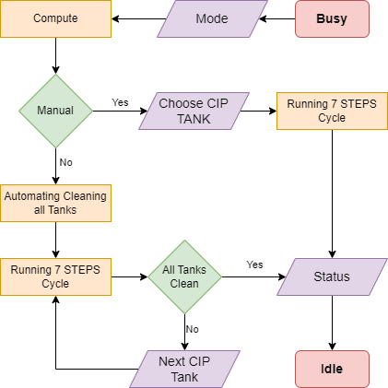

1. Mode control algorithm flowchart
   * 1. Step 1: Pre-empty

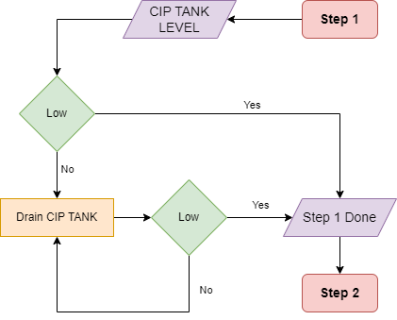

1. Step 1 control algorithm flowchart
   * 1. Step 2: Re-supply

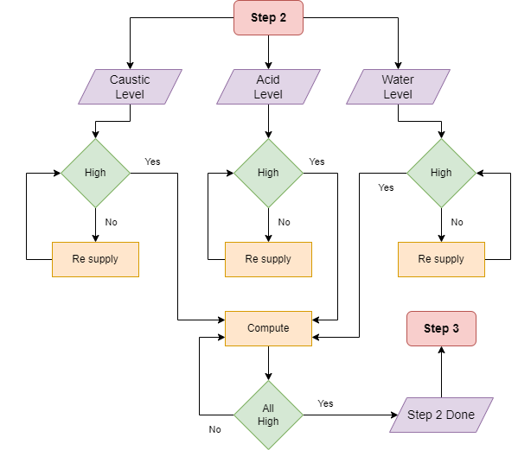

1. Step 2 control algorithm flowchart
   * 1. Step 3+5+7: Pre-rinse / Intermediate rinse / Final rinse

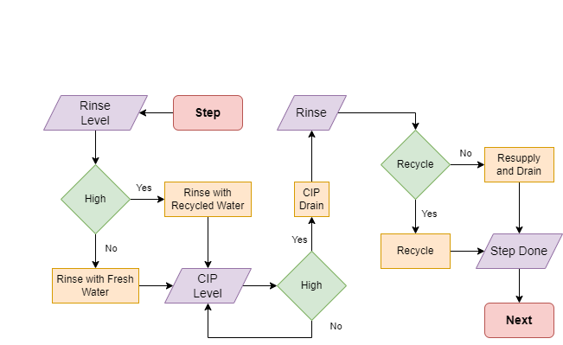

1. Rinse step control algorithm flowchart
   * 1. Step 4+6: Caustic wash / Acid wash

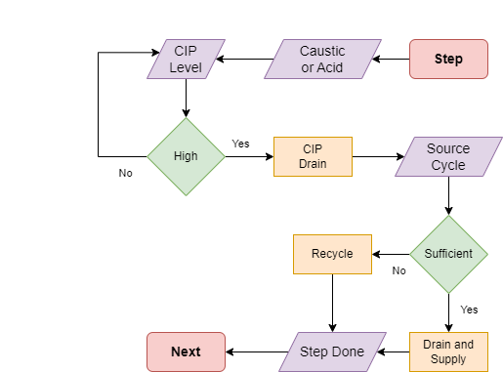

1. Caustic / Acid wash control algorithm flowchart
   1. Authorization Distribution

The access authorization is divided into 3 levels: admin (can field, read report and setting for user); operator (can field report and access on HMI for operating); guest (can remotely read reports).

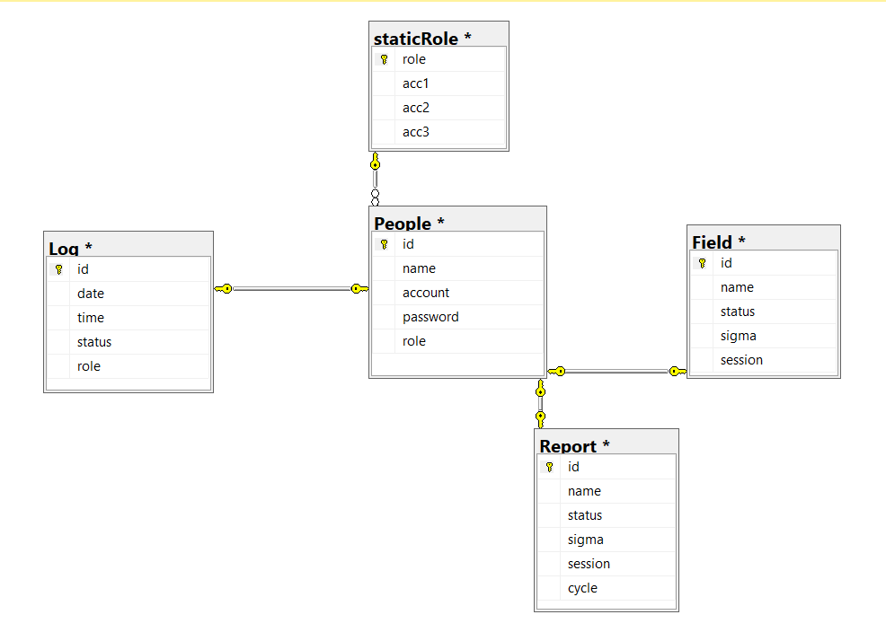

1. User, log and report database relationship
2. Simulation
   1. User Login

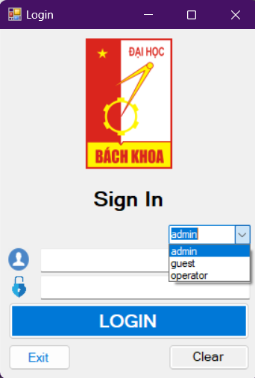

1. User login form
   1. Admin forms
      1. Setting

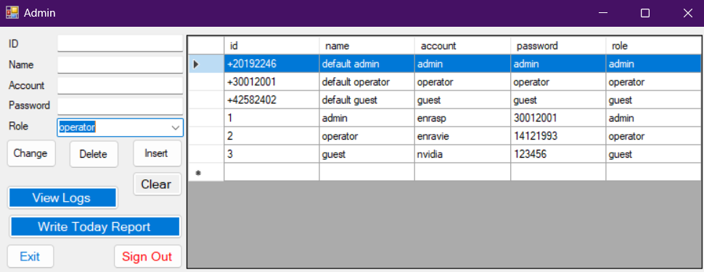

1. Administration settings
   * 1. Logs

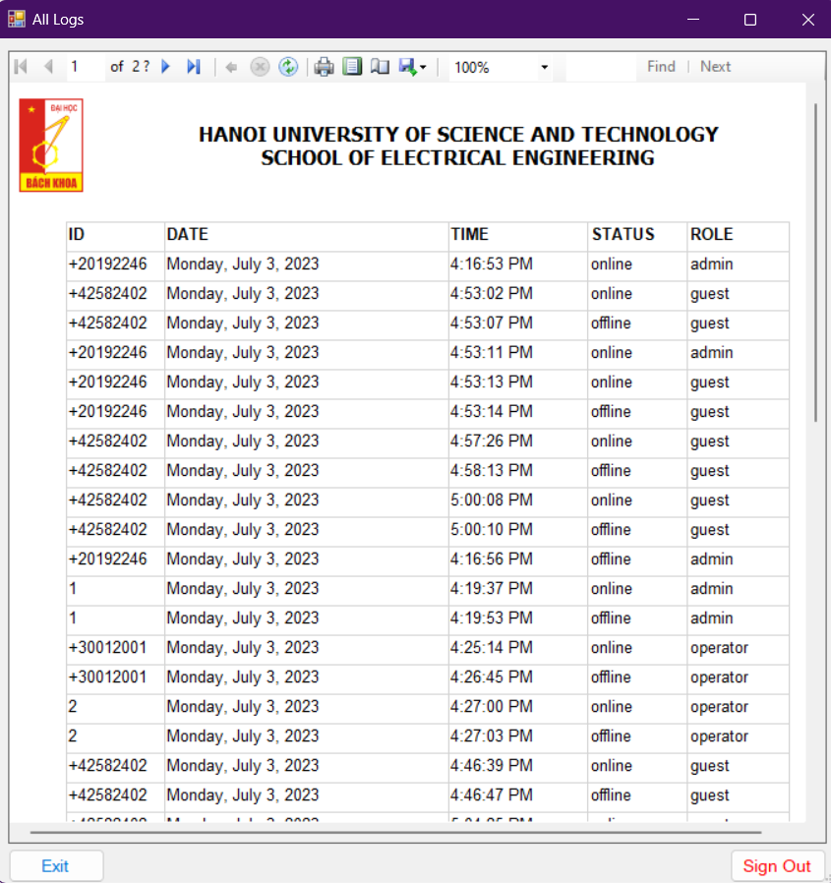

1. User logs
   * 1. Report

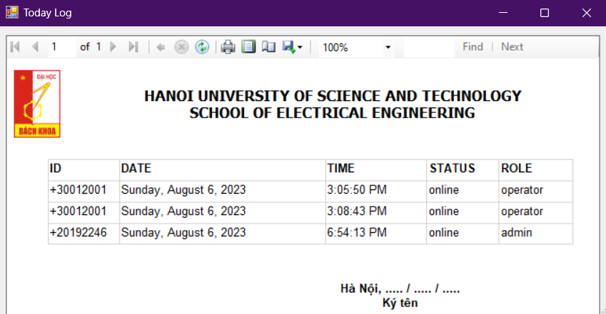

1. Reports
   1. Operator forms

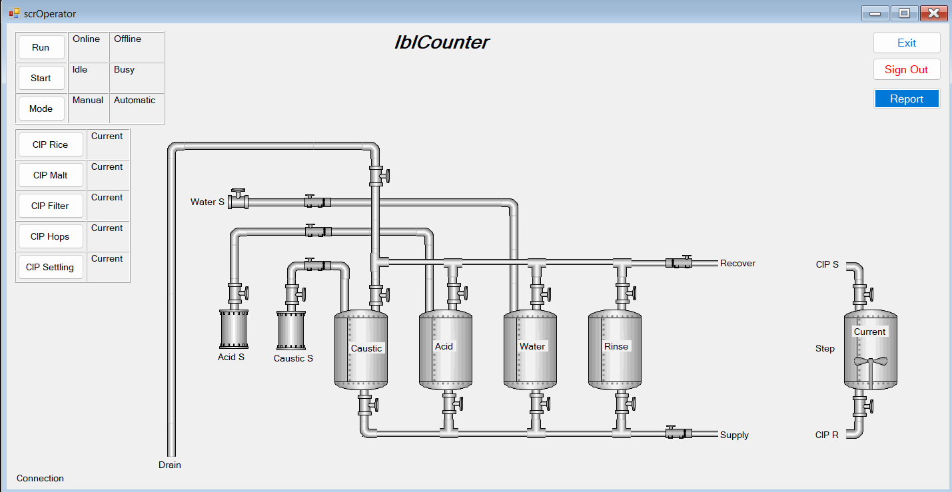

1. Operator forms

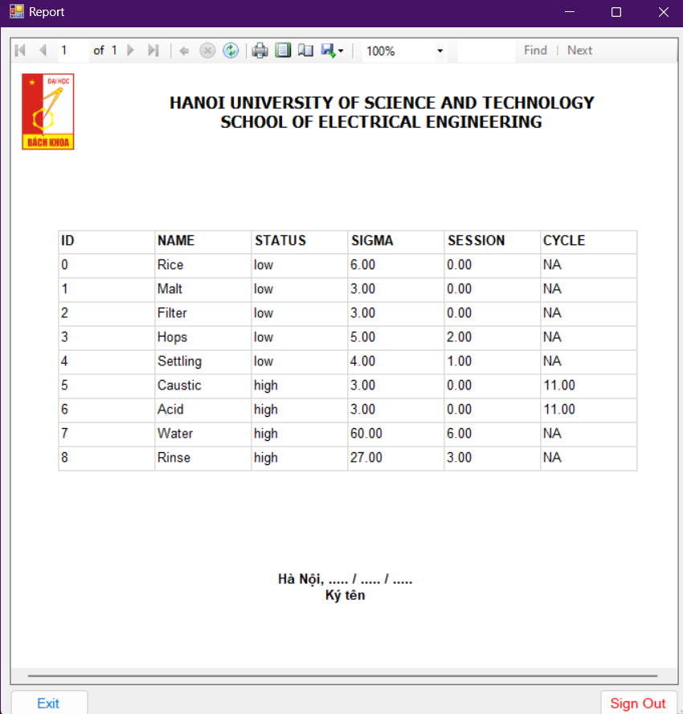

1. Operator report
   1. Guest view

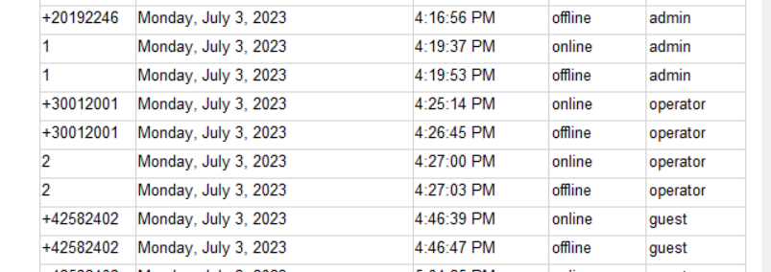

1. Guest views
   1. HMI for operator

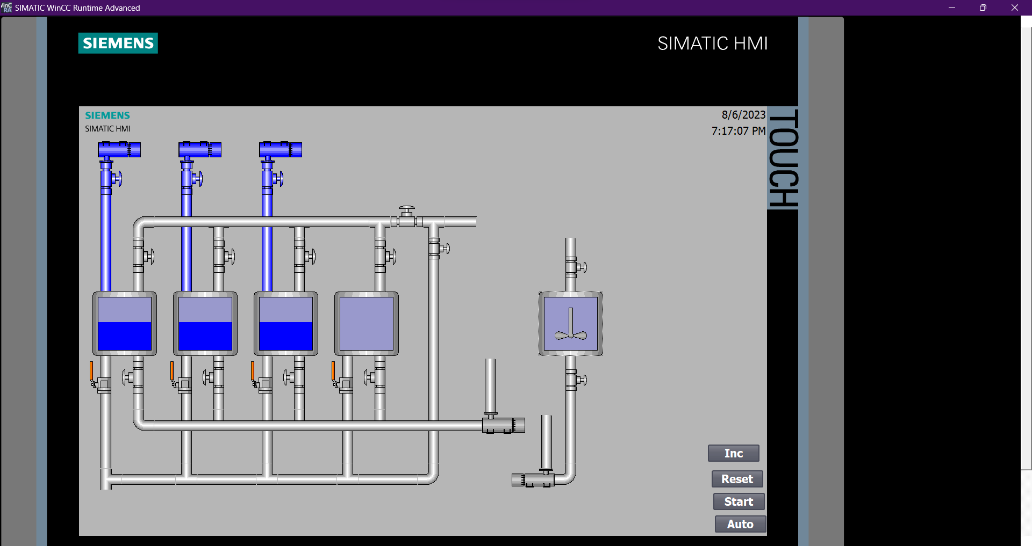

1. Resupply process

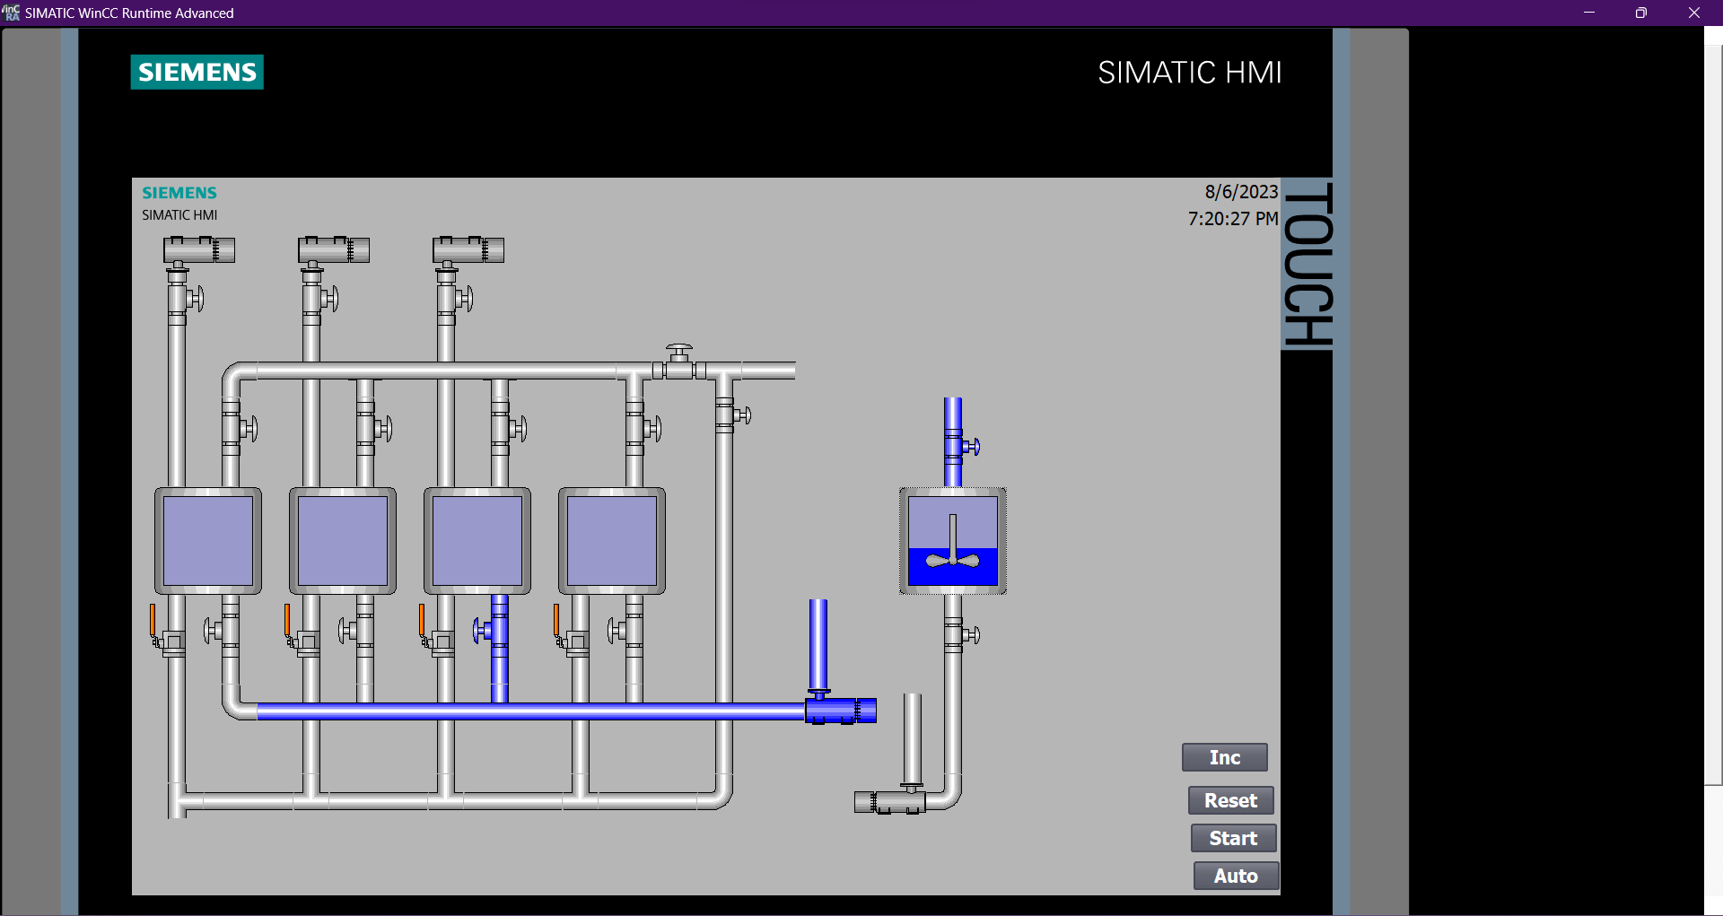

1. Pre rinse process
2. Conclusion

After a period of active and efficient work during the recent semester, the project has essentially been completed on time and has met the required specifications and criteria. However, due to the team's limited practical experience and insufficient domain knowledge, there are still some areas of the project that have not been optimized and require improvement for practical application in the real work environment. We are very grateful to the instructor for their support and attentiveness to the challenges we faced during the project's execution. We hope to receive more feedback and suggestions to enhance the practicality of the project in the future.

Further inspection and adjusting will need to be done through more and more experiments.

Files and data of this project will be uploaded to drive:

<https://tinyurl.com/192246DCS-SCADAG220>

